Starting the Conversation:
Do you want to talk about your child?

WORKBOOK

For program facilitators and participants
Jeneva L. Ohan, Kim Eaton, and Patrick W. Corrigan

Starting the Conversation (STC) is derived from the Honest, Open, Proud was formerly known as Coming Out Proud to Eliminate the Stigma of Mental Illness. For information, contact Patrick Corrigan (Corrigan@iit.edu) or visit the website at www.hopprogram.org
Version: 07/2017

TABLE OF CONTENTS

Lesson 1. Consider the Pros and Cons of Disclosing 6
- Stigma affects children and their parents 6
- Considering how this might impact you 10
- Consider the pros and cons of disclosing 15
Lesson 2. There are Different Ways to Disclose 23
- Different ways to disclose 23
- How might others react? 28
- Developing your coping plan 33
Lesson 3. Telling Your Story 36
- What would you like to say? Disclosing from a position of strength 36
- How would you like to disclose? 47
- Try it out 50
- Putting it all together 52
- Looking ahead 55

Final Session. 57
- Who did you intend to talk with, and who have you talked with? 57
- Where to find support 61

Appendix 1. Challenging Personally Hurtful Self-Stigma 63
Appendix 2. Extra Forms 68

PREFACE
This is the companion workbook to the Starting the Conversation (STC): Do you Want to Talk About Your Child? program manual. The program is meant to be flexible and can be done in different formats based on feedback received from STC facilitators. For example:
- STC might be completed as a day-long seminar of about 6 hours with a 2-hour ‘final session’ about one month later.
- It can be done as three 1.5 to 2-hour sessions that includes the ‘final session’ about 1 month later (as outlined in the Table of Contents)
- STC can be administered in 7 sessions of up to 1 hour, with each corresponding to the tasks under each lesson.
Facilitators should decide among these options based on needed accommodations of program participants.

In this workbook, lessons/tasks are laid out with learning points, discussion questions, and group exercises. Individual lessons directly correspond to sections of the program manual. This program is best run with 4 to 8 participants. One or two people should facilitate, preferably people who are or have been parents/caregivers of children with mental health challenges. All that is needed to run this program is a private room, manuals for the facilitators, and paper copies of the workbook for each participant.

An Important Note.
Please note that families should find out about what laws, regulations, or policies (etc) exist around disclosure for a child’s diagnosis in their particular situation. For example, disclosure might be needed to gain access to services for a child, or might be legally required in some situations (e.g., field trips that involve overnight stays). This Manual and the Workbook do not comment on these, and can’t be held accountable for these.

Although we use the term ‘parents’ throughout the program for simplicity’s sake, this term is intended to refer to any caregiver of a young child with mental health challenges. All materials in this workbook and in the program manual can be downloaded for free on the program website. (www.hopprogram.org.).

Starting the Conversation: Do you Want to Talk About Your Child? Is based on the Honest, Open, Proud program, which is a program of NAMI-Chicago:
Patrick Corrigan, Director, corrigan@iit.edu
Kyra Wilson, Assistant Director, kyra@namigc.org

The original Honest, Open, Proud program is made possible by a generous donation from Patricia Price

Acknowledgements
The ideas herein are a draft in progress. Many thanks, however, to those who have contributed to advising us on appropriate content, given us feedback on drafts, and helped us to make the program meaningful, including Maria Daniele, Janine Giles, Riona Johnston, Shannon Reid, and Hilary Sherlock.

About the Authors
Jeneva Ohan, PhD, is a mother of 3 children, psychologist, and senior lecturer at the University of Western Australia. Kim Eaton is a PhD candidate in psychology at the University of Western Australia. Patrick Corrigan, Psy.D, is a person with mental illness (major depression and anxiety disorder) who is a distinguished professor of psychology at the Illinois Institute of Technology, Chicago Illinois, USA.
Starting Each Lesson

The first thing at the beginning of each lesson is set the tone. We start by having facilitators provide their names and any other introductory information they would like to share. Facilitators should then go around the room and ask each participant to share their first name (last names and titles are not necessary unless the person chooses to share this information). After introductions, facilitators should state the overall purpose of the program:
“Our goal here is to consider what the costs and benefits are of disclosing a child’s experiences with mental illness to some people. We also seek to discuss strategies for disclosing most effectively should you decide to do so.”
Facilitators should also establish some general ground rules with the group:
- Confidentiality- what is said in the room stays in the room,
- Everyone’s opinion counts, and
- We respect each other.
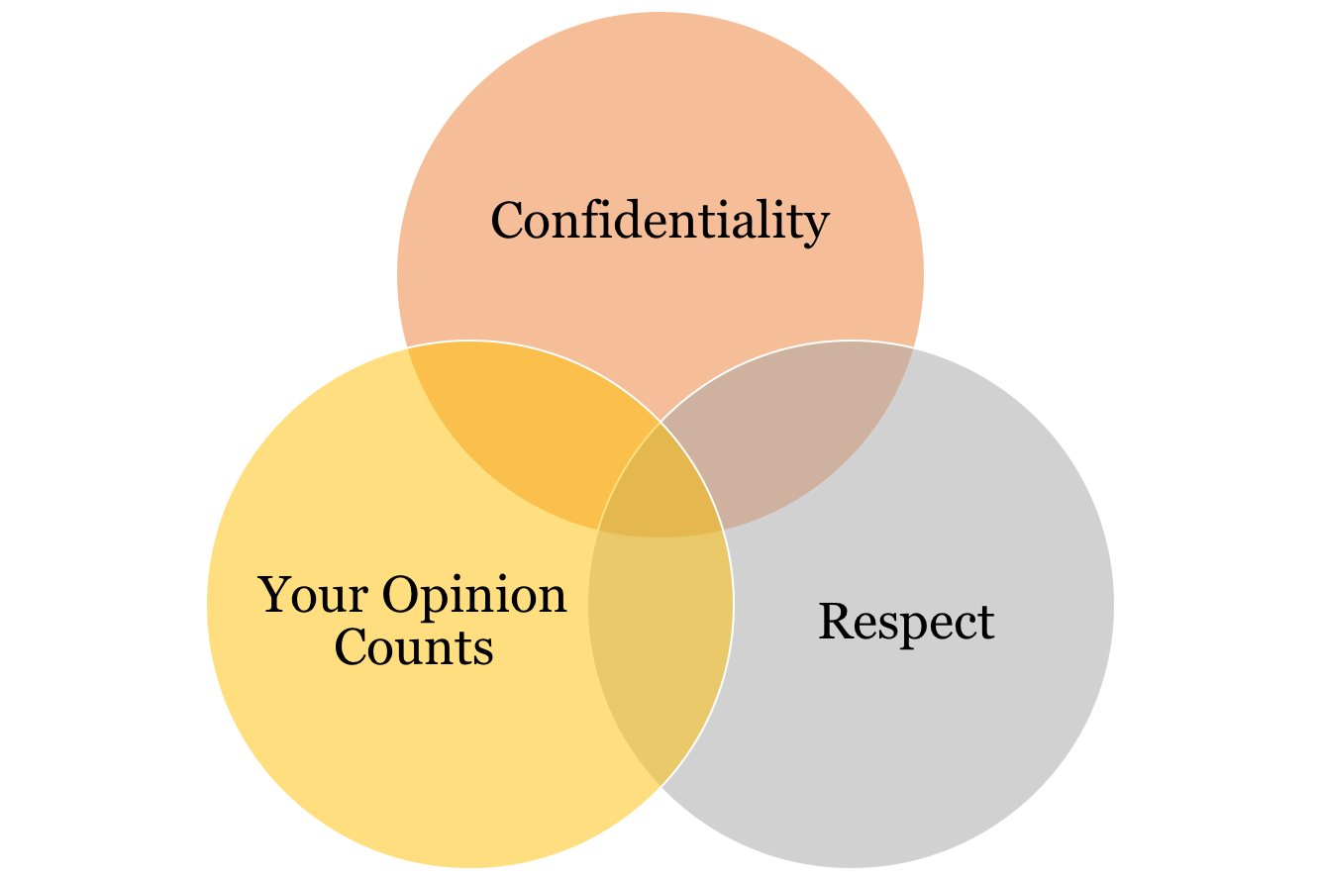
Introductions and ground rules should be repeated at the start of all meetings
The goal is to create an open environment where people feel comfortable sharing their opinions and feelings should they choose to do so.

LESSON 1

Considering the Pros and Cons of Disclosing

LESSON OVERVIEW
Openly discussing your child’s mental health challenges is the right decision for some people, but not for everyone. This section is a guide to help parents decide which decision is right for them. We approach the decision in three parts:
- We discuss how both children and their parents are harmed by stigma.
- How might this impact you?
- We help you weigh the costs and benefits of disclosing your child’s challenges to others, so that you can decide whether or not to disclose.
Task 1. Stigma Affects Children and their Parents.

LEARNING OBJECTIVES
- Think about how both children with mental health challenges and their parents can be targets of stigma
- Consider how parents would like to label their child’s current challenges

One reason why parents do not want to tell others about their child’s mental health challenges is because they are afraid of stigma.
Stigma: negative or unfair beliefs about or actions towards a group of people.

Both children with mental health challenges and their parents can be stigmatised.

When you are making decisions about talking to others about your child’s challenges, you’ll need to consider stigma towards both you and your child, so let’s take some time now to consider some of the stigmas that might concern you. Take a look at Table 1.1. Is there anything that you would like to add?

Table 1.1: Examples of some stigmas towards children with mental health challenges and their parents. Are there any you would like to add?
Stigmas towards Children with Mental health challenges | Stigmas towards Parents of Children with Mental health challenges
“ “These kids are just lazy” | “These parents are unfit”
“ “These kids shouldn’t be in the same class” | “Parents just want a label so they can get medication”
“These kids are a bad influence” | “If these parents knew what they were doing, the problem would be solved.”

Neither stigma is more or less important than the other. It’s important however, to keep in mind WHICH stigma you are addressing later on.

Can diagnoses or labels make this worse?
Sometimes parents are concerned about the diagnosis, or label, that their child has been given because labels can worsen stigma. Words can be powerful and society can stigmatize some terms more than others.

There are many ways that we talk about mental health challenges. In this program, we will use the term “mental health challenges” because most parents prefer that term. You may have another term that you prefer to use. You can let others in the group know about how you would like to refer to your child’s challenges.

Let’s read about stories Michelle and Jason’s stories.

Michelle is 32 years old and has a son who was diagnosed with attention-deficit/hyperactivity disorder—inattentive type last year. She refers to his challenges as “A.D.D.” when she talks to others about her son’s difficulties.

Jason is also 32 years old, and has a son who was recently diagnosed as having attention-deficit/hyperactivity disorder—inattentive type. He refers to his son’s challenges as ‘an inattentive disorder’ when he talks to others.

Neither Michelle nor Jason use ‘ADHD’ to refer to their child’s challenges. However, they have both chosen different ways to refer to similar difficulties.
What term would YOU like to use? Try Worksheet 1.1.

Worksheet 1.1
Finding a term that fits for you.

How would you like to refer to your child’s challenges? What are the pros and cons?

Term you would like to use for your child’s challenges:
PROS | CONS

This is not a one-time decision! People might change their minds about how they would like to refer to their child’s challenges.

Note also that this is a decision that should take into consideration any laws, policies, requirements, and so on, that exist in your/your family’s situation. For example, you might be required to disclose in order to gain access to services for your child, or you might be required to disclose in completing school forms (e.g., that ask about diagnoses or needs). Please ensure that you conduct your own research into what issues impact on you and your child in making these decisions.

Task 2. How Might Stigma Impact You?

LEARNING OBJECTIVES
- Some parents agree with stigma that is directed towards them, and beat themselves up as a result.
- Try challenging these thoughts.

There is another reason why we started off talking about stigma towards children and their parents. This is because parents can take the stigma that they are aware exists about parents of children who have challenges similar to their own child, and believe it about themselves.
For example…
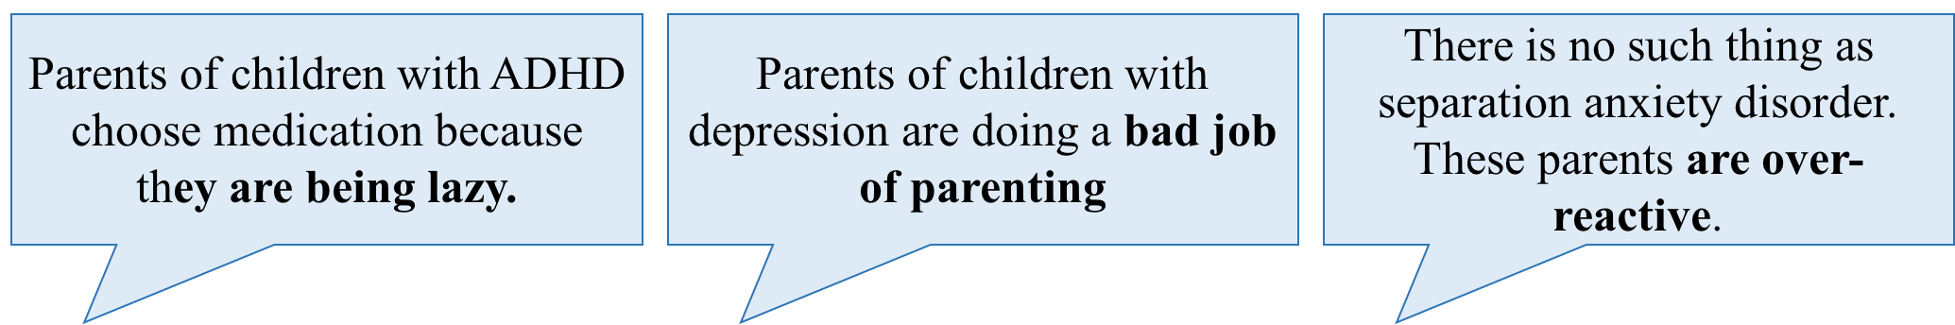
Stereotypes like these are in the same immoral class as racist, sexist, and ageist comments. Unfortunately, some parents of children with mental health challenges agree with stigmatizing beliefs like these and internalize them.
For example…
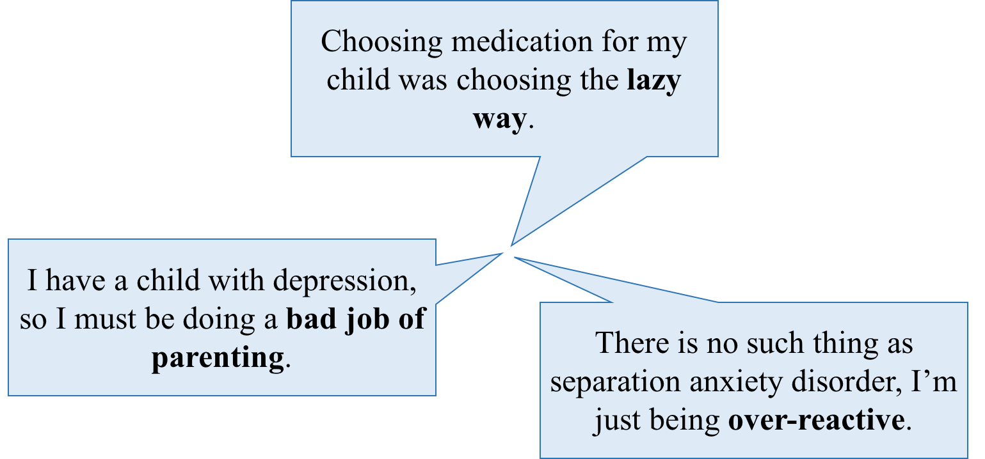

This is called Self-Stigma.

Challenging Personally Hurtful Self-Stigma
Do you have personally hurtful beliefs like these? Ask yourself, in moments that are really tough as a parent, what thoughts do you have about yourself? If some of these seem like self-stigma, then write them down here... and we will think about a way for you to challenge it.

Personally Hurtful Self-Stigma that I can have:

Just like stigma that others hold, this self-stigma is painful for and unfair to you.
Let’s look at 5 steps to changing this:

Step 1.
Begin with a clear statement of the hurtful attitude you are holding like this:

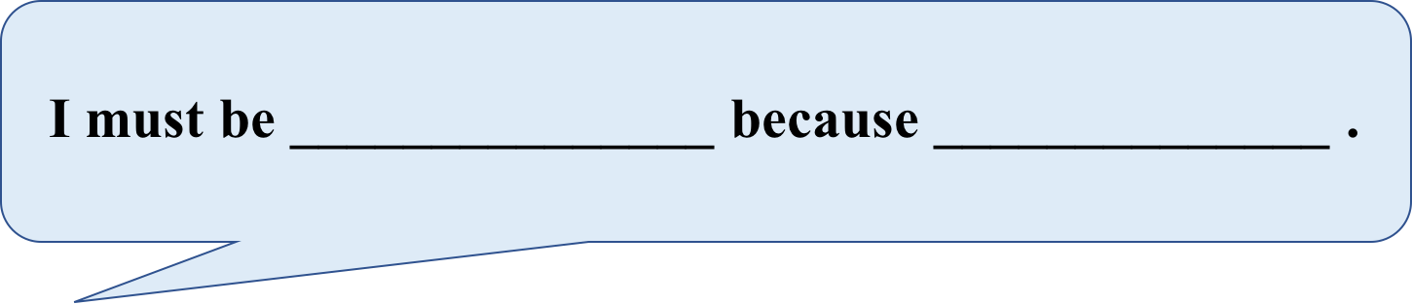
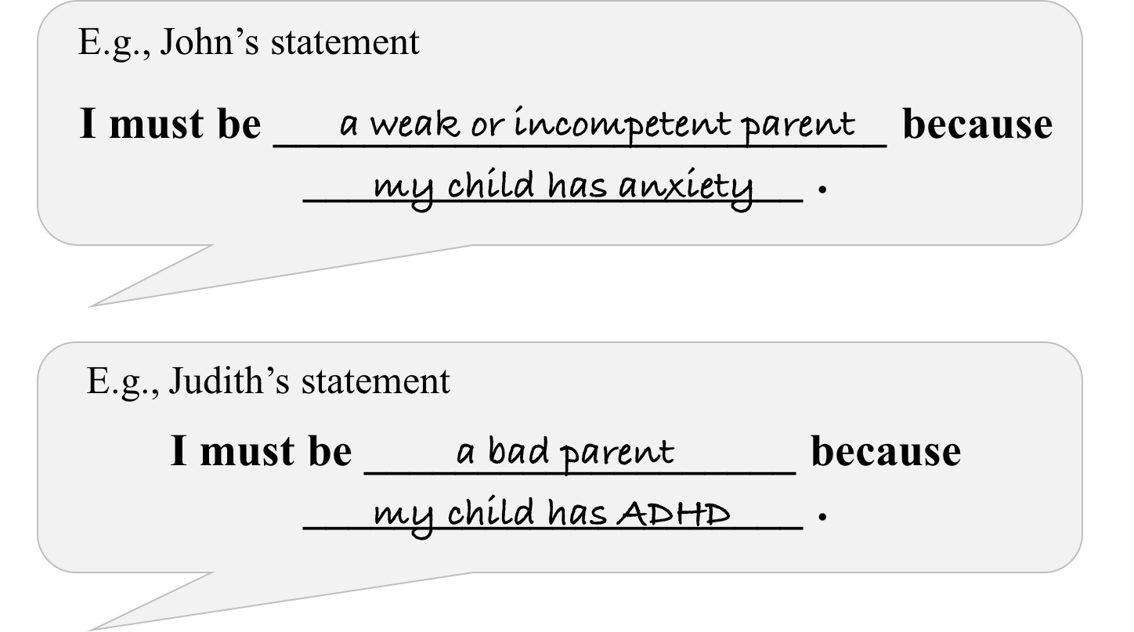

Step 2.
Change this statement into a true-false statement about parents in general.
For John’s example above:
Only parents of children with anxiety (or other challenges) are weak and incompetent. Parents of children without anxiety never feel weak or incompetent due to their challenges.

If you believe this, you will feel worse about yourself.
For Judith’s example, what would it be?
______________________________________________________________________________________________________________________________________________________________________________________________________________________________
Step 3.
Challenge this by looking for evidence. You could ask others you trust if they believe them to be true. If others you trust don’t hold these beliefs, then that is good evidence for you to reject your thought.
For example, John could seek out some people he trusts – a close friend or cousin. These people might say that parents of even the ‘best behaved’ kids struggle and feel ineffective. Maybe they have sought help from others at times, perhaps their family doctor, a counsellor, or self-help books.
Similarly, Judith might ask her GP about the causes of ADHD because she trusts her GP to know about the science behind what causes ADHD. Her GP tells her that there is no evidence that ADHD is caused by parenting.
Step 4.
This step is to pause and look at the evidence you have gathered. In other words, after talking with these trusted people you might find that your hurtful belief (for John, that parents of children without anxiety never feel weak or incompetent due to life challenges) is not true.
Step 5.
The final step is to use your findings to develop a new attitude that counters (or is contrary to) the hurtful belief. For example:
“I'm not a bad parent for feeling weak. Every parent does at times.”
What could Judith write?
___________________________________________________________________________________________________________________________________________________

Maybe write the ‘counter-belief’ down on a card so that you remember it better (an example is given below). The next time that you feel bad for weakness, pull out the card. Remind yourself that every parent feels weak once in a while.

Date:
COUNTER TO:
I AM WEAK!

Would this exercise help you?
If so, try Appendix 1 on page 63.
Holding on to your ‘counters’ can help you in the future… whether or not you decide to disclose!

Task 3. Considering the Pros and Cons of Disclosing

LEARNING OBJECTIVES

- There are both benefits and costs to disclosing – and not disclosing – your child’s challenges.
- Only you can weigh them to decide whether the pros outweigh the cons.
- Costs and benefits differ depending on who you are telling.

There are many benefits (pros) and costs (cons) to telling others – and not telling others – about your child’s mental health challenges.
These can be for you and/or your child.

Worksheet 1.2a: Pros and Cons of Disclosing
List all of the pros and cons of disclosing your child’s mental health challenges.
Think about both you and your child when making this list.

Table 1.3: Some Costs and Benefits of Telling Others about my Child’s Challenges
☑ ☒
Benefits | Costs

Worksheet 1.2b: Pros and Cons of Disclosing

Now let’s make a different kind of list. Write down the costs and benefits of NOT DISCLOSING. Think about both you and your child when making this list.

Table 1.4: Some Costs and Benefits of Not Disclosing
☑ ☒
Benefits | Costs

What stands out for you? Put a check next to any that are especially true for you and your family.

Putting it all together: Weighing the Costs and Benefits of Disclosing
Only you can judge what the costs and benefits are of your decision.
Before you make your decision, we want you to consider other keys of disclosure.

After listing all the costs and benefits, put a star next to one or two that seem to be particularly important. Important items are the ones you spend a lot of time thinking about. You may want to star (*) the items that make you nervous when you think about them. Or, you may mark items that suggest a lot of hope.

What is your decision? The purpose of Worksheet 1.3 is to decide about whether or not to talk about your child’s challenges with others.
On the worksheet, you will see a decision you can make:
HOMEWORK

Let’s get started on Worksheet 1.3 on the next page. While you are filling out the worksheet remember: benefits are the reasons why you would want to disclose. Ask yourself the question, “How will letting other people know about my child’s challenges help?” Costs are the disadvantages… Ask yourself: “How will talking to others about my child’s challenges hurt?”

Remember, only you can decide for yourself how these costs and benefits balance.

There are a few copies of Worksheet 1.3 for you to do as homework, and you can make as many more as you like. Think of someplace or someone currently important to you to whom you might disclose. This homework is given to you for the purpose of helping you make a decision, you are not expected to turn it in or share it with anyone. You may find yourself filling out the Costs and Benefits Worksheet several times in your life and coming up with different conclusions each time; that’s okay. Appendix 2of the workbook has five blank copies of Worksheet 1.3 for you to complete in the future.
Worksheet 1.3
The Costs and Benefits of Talking with Others about my Child’s Challenges
Setting: To Whom:
Write all of your ideas down.
Put a star (*) next to costs and benefits you think are especially important.

Short-Term Benefits  ☑ ☒ | Short-Term Costs

Long-Term Benefits  ☑ ☒ | Long-Term Costs
Given these costs and benefits:
I have decided to disclose my child’s challenges.
I have decided NOT to disclose my child’s challenges. I have decided to put off my decision.

What is your GOAL in disclosing? (Consider reasons you listed in Worksheet 1.2a)

What do you expect will happen after disclosing?

The Costs and Benefits of Talking with Others about my Child’s Challenges
Setting: To Whom:
Write all of your ideas down.
Put a star (*) next to costs and benefits you think are especially important.

Short-Term Benefits  ☑ ☒ | Short-Term Costs

Long-Term Benefits  ☑ ☒ | Long-Term Costs
Given these costs and benefits:
I have decided to disclose my child’s challenges.
I have decided NOT to disclose my child’s challenges. I have decided to put off my decision.

What is your GOAL in disclosing? (Consider reasons you listed in Worksheet 1.2a)

What do you expect will happen after disclosing?

LESSON 2

There are Different Ways to Disclose

LESSON OVERVIEW
It might seem obvious, but there are different ways to talk about your child’s challenges.
- We describe five ways here, and then guide you through considering the costs and benefits of each.
- We then consider how others might respond to your disclosure.
- We then make a coping plan for how to handle it when you receive negative reactions.

Task 1. Different Ways to Disclose

LEARNING OBJECTIVES

  - Parents might disclose their child’s challenges and treatments in different ways.
  - Understand the costs and benefits of disclosing in the five different ways.
  - Remember, you will perceive different costs and benefits associated with each of the five ways. The costs and benefits you identify may vary by setting.

Last week, you completed Worksheet 1.3, and decided who, if anyone, you would like to talk with about your child’s challenges. You may have come to the decision to tell nobody, to tell a few people selectively, to tell most people, or even to be very open to everyone about your child’s challenges.
These different options are listed below in Table 2.1.

Table 2.1: Five Ways to Talk (or Not Talk) to Others
1. SOCIAL AVOIDANCE: Not telling anyone about your child’s challenges and avoid situations where people may find out about it. Because this would include school, you might decide to home-school your child.
Benefit: You don’t come across people who will unfairly harm you and/or your child. | Cost: Isolating yourself and your family. Difficult and stressful to do with children, as you cannot control their symptoms in all places. You might be put on the spot at your child’s school and need to discuss it.
2. SECRECY: Participating in work and community situations, but keeping your child’s challenges a secret
Benefit: Like social avoidance, you withhold information about your child’s challenges. But, you don’t avoid important settings like your child’s school, so you can achieve advocacy there. | Cost: Some people feel guilty about keeping secrets. You may also receive less support from others because they are unaware of your child’s difficulties.
3. SELECTIVE DISCLOSURE: Disclosing your child’s challenges to selected individuals, like their teacher and your close friends, but not to everyone.
Benefit: You find a small group of people who will understand your experiences and provide support. This enables broader advocacy for your child | Cost: You may disclose to some people who then hurt you with the information. You may have difficulty keeping track of who knows and who doesn’t.
4. INDISCRIMINANT DISCLOSURE: Making the decision to no longer conceal your child’s challenges; this does not mean, however, that you are telling everyone everything.
Benefit: You don’t worry who knows about your child’s challenges. You may find people who will be supportive. You may find advocacy easier. | Cost: You may tell people who then hurt you with the information (e.g., by disbelieving, stigmatizing, or exaggerating to others).
5. BROADCAST YOUR EXPERIENCE: Actively seeking out and educating people about your child’s challenges.
Benefit: You don’t have to worry who knows what. You are promoting empowerment, and a personal sense of empowerment in yourself. You’re striking a blow against stigma. | Cost: You are going to encounter people who try to hurt you with this information. You are going to meet people who disapprove of your decisions.

They can be thought of a bit like this:

Selective Disclosure: Disclosing your child’s challenges to selected individuals, like their teacher and your close friends, but not to everyone

Social Avoidance: Not telling anyone about your child’s challenges, and avoiding places where others might find out.
Secrecy: Participating in work and community situations, but keeping your child’s challenges a secret
Broadcasting: Actively seeking out and educating others about your child’s challenges
Indiscriminant Disclosure: Making the decision to no longer conceal your child’s challenges
Worksheet 2.1
What are your Costs and Benefits of the Five Ways to Disclose?
Selective Disclosure:
PROS CONS:

Social Avoidance:
PROS:

CONS:
Broadcasting: PROS:

CONS:
Secrecy:
PROS

CONS

Indiscriminant Disclosure: PROS:

CONS

The main point here is to recognize that there are advantages and disadvantages with each decision, and that everyone has the right to choose their own approach as to what will work best for them considering their child, self, and situation.

Task 2. How Might Others React?

LEARNING OBJECTIVES

  - Disclosure will impact you, your child, and others around you.
  - Others may react in very different ways.
  - These reactions might surprise you. Take time to consider the different ways that people will react.

If you talk about your child’s challenges, this will impact the people around you. Whether you choose selective disclosure or broadcasting, those who hear what you have to say are likely to react, and some of these reactions might be surprising. You need to consider the different ways people may respond, and plan what your reactions will be.

So, take time to look at Table 2.2 on the next page. There are a variety of reactions to disclosure, which are grouped based on whether the reaction is positive or negative.
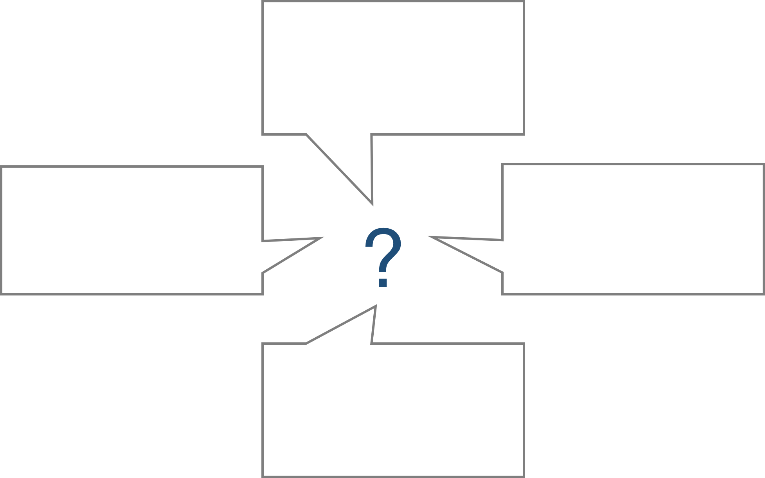
Preparing for this would make me feel more empowered
You can practice but as soon as one person says it’s all rubbish, you forget everything.
When you talk about your child’s challenges, you are very vulnerable
I have brilliant
comebacks….
30 minutes later

Table 2.2: How People Might Respond
Positive | Negative
Understanding  “It must be hard living with your child’s challenges and feeling like you can’t talk about it.”  Interpersonal Support  “I’m here for you if you need someone to talk to.”  Assistance  “Can I pick up your elder child after school if you need to go to the doc?” | Disrespect to you  “I just don’t think that medication should be given to kids.”  Denial  “There’s no such thing as ADHD.”  Retribution towards your child  “I’ll make sure your kid doesn’t get invited to birthday parties.”  Fear/Avoidance of you or your family  “Your kid is dangerous. I need to keep my kids away from her.”  Gossip about your child  “Hey, did you hear about John? He was just diagnosed with ‘bipolar’.”  Blaming you  “The apple doesn’t fall far from the tree.”

Place a * next to those you have experienced. Are there other examples? List them here.

▪
▪
▪
▪
▪

How will YOU respond?
Let’s get a feeling for how you will respond emotionally to negative, hurtful feedback. Worksheet 2.2 on the next page gives you a chance to try out how it might feel to talk about your child’s challenges. Find a partner and role-play talking about your child’s challenges. Say something that you would like to tell a parent of your child’s friend. The example in Worksheet 2.2 is “My child was diagnosed with ADHD and depression late last year.” Then ask your partner to say response 1: “What is your child doing in this school?” Pause a few seconds and repeat your comment. “My child was diagnosed with ADHD and depression late last year.” Ask partner to say response 2. Continue in this way.

The goal of this exercise is not to practice what you will say, or what you will do. The goal is to get a sense of how you feel when someone you talk to responds harshly. When done with the task, complete the four items below the box. Scores above a 4 on any scale in Worksheet 2.2 may suggest that these kinds of insults will hurt you. You are reporting significant feelings of shame, anxiety, sadness, or anger because of hurtful comments. You need to ask yourself whether or not you want to put up with this kind of grief. And, remember, a comment from a partner in a role-play has far less sting than a remark from a co-worker or friend in real life.

Worksheet 2.2
Your Reactions when Others’ Respond Negatively

Find a friend to role-play the following.
You are with a parent of your child’s friend and say:
“My child was diagnosed with ADHD and depression late last year.”
(OR, put your example here) ______________________________________
Your role-play partner says:
“What is your child doing in this school?”
“That’s society these days… everyone has ‘ADHD’”
“There was no ‘ADHD’ back in my day”
“ADHD isn’t a real thing, it’s just poor parenting”

”ADHD AND depression! You’re not doing very well at being a parent then are you?”
“I suppose you put your child on meds for the sake of a quiet household”

After listening to these comments, rate yourself on the scales below.
Circle the number that best represents how you feel in response to these statements.
 | not at all  ashamed |  |  | moderately  ashamed |  |  | very  ashamed
 | 1 | 2 | 3 | 4 | 5 | 6 | 7
 | not at all  nervous |  |  | moderately  nervous |  |  | very  nervous
 | 1 | 2 | 3 | 4 | 5 | 6 | 7
 | not at all  sad |  |  | moderately  sad |  |  | very  sad
 | 1 | 2 | 3 | 4 | 5 | 6 | 7
 | not at all  angry |  |  | moderately  angry |  |  | very  angry
 | 1 | 2 | 3 | 4 | 5 | 6 | 7

Task 3. Developing Your Coping Plan

LEARNING OBJECTIVES

  - Not everyone you talk with will be supportive
  - Decide on what you would like to say or do when someone you talk with reacts negatively.

Not everyone you tell about (or who find out about) your child’s difficulties will be supportive. Some comments can be very hurtful, and they might be when you least expect it. You could try to think of what to say to all different types of negative reactions. However, you might forget in the moment, and it is hard to think of all the different types of things people can say about parents and kids with mental health challenges and then remember a response to each. Developing a coping plan might be a good way to prepare for times like these. A coping plan is a set of strategies to help you deal with something that is emotionally hurtful or upsetting. The idea is to help you reduce your stress or hurt feelings.

Take a look now and try completing Worksheet 2.3, ‘Coping with Others’ Negative Responses.’ You may wish to refer back to this worksheet if you need it in the future. Take some time to do this worksheet before we move on.

Worksheet 2.3
Coping with Others’ Negative Responses

Here is what I will tell myself:
Think of positive self-talk, like “I’m doing what is best for my child,” “I know that I have done nothing wrong here,” “I know my child is improving,” and so on…

Here is someone I can talk to who I can count on:

This could be someone in this group, a good friend, or a family member

HOMEWORK

You can keep on changing this, and refer back to it if you need it now or in the future.
For Homework, continue to think about your reactions. Make sure you complete Worksheet 2.3 before the next session. Next week we’ll talk about how to discuss your child’s challenges if and when you decide to – that includes who you’d like to tell what to, and how.

LESSON 3
Telling Your Story

LESSON OVERVIEW
As a result of Lessons 1 and 2, you might have decided that you want to talk to others about your child’s challenges now, or perhaps in the future.
This last lesson has several goals.
Task 1 How to decide what you would like to say
Task 2 Deciding how you would like to tell it
Task 3 Practice trying it out. How did it go?
Task 4 Putting it all together
Task 5 Looking ahead

Task 1. What would you like to say?

Disclosing from a position of strength

LEARNING OBJECTIVES

  - Sort through your ideas on what you would like to say
  - Decide on what you would like to say.

You do not have to disclose everything to everyone. Consider some key questions:
- Will this help (or hurt) my child?
Will this hurt, help, or neither? Or a combination I need to weigh up?
- Will this help (or hurt) me and/or others I care about?
What about others I care about (e.g., a partner, other children)?
- Have I included everything that I want to, including what is relevant?
I don’t need to say everything, but enough to meet my goals
- Have I presented myself and my child with dignity?
Did I present my child’s challenges as just one part of my child, without being overly positive or negative?

Now take a look at Worksheet 3.1 on the next page, but leave the very last question till later – we’ll work our way through that shortly. Think of someone you would like to talk to about your child’s challenges, and place his/her name at the top (there are extra copies in Appendix 3 for you to do this with others). Now, take some time to think about what you would like to say with these four things in mind.

Worksheet 3.1
How to Talk about my Child’s Challenges

1. Who you are planning to talk to:___________________________________
2. What are your goals?____________________________________________
_____________________________________________________________
3. What would you like to say? You can include any or all of the below to help you achieve your goal.
a) A description of your child.
You may wish to start with a description of who your child is (e.g., likes/dislikes personality/temperament). Your child’s challenges are just a part of your child.
1.
2.
3.
b) What your child’s challenges are.
You may / may not wish to include the name of the disorder, and how you came about that diagnosis (e.g., a psychologist).
1.
2.
3.

c) When your child first started showing these challenges.
List your child’s age and some of the things you first noticed when these challenges started.
1.
2.
3.

d) Some of the challenges that still continue for your child today.
List some of the things that your child struggles with now.
1.
2.
3.
e) Some of the struggles you face as a parent.
List some of the things that you struggle with now.
1.
2.
3.
f) Unfair reactions to your child’s challenges, and/or to you.
1.
2.
3.
4.
g) Things that work.
What are some strategies or treatments that work that you would like to include?
1. _
2.
3.

h) Despite these challenges and sometimes because of them, point out some of the accomplishments that you and/or your child have achieved.
What are your child’s characteristics that make you proud?
1.
2. _
3.
4.

i) Anything else?
1.
2. _
3.

Consider ending with these key points:
- My child is like all children.
- So, please treat my child fairly.
- I am doing my best as a parent.
- So, please treat us fairly.
Worksheet continues over page

Now REVIEW
You might not want to communicate EVERYTHING here.
Remember your GOAL (from Worksheet 1.3).

- Will this help (or hurt) my child?
- Will this help (or hurt) me and/or others I care about?
- Have I included everything that I want to, including what is relevant?
- What am I comfortable saying?
- Do I feel confident that I could say this?

- CIRCLE the information in the sheet you think is important for the person to hear.
- PUT A LINE through any information you decide not to share.

How would you like to relate this to this person (e.g., email, letter, in person…)? *save this answer for the next task

There are more of these worksheets on the next few pages so that you can do this for homework for other people… make as many copies as you need.
Worksheet 3.1
How to Talk about my Child’s Challenges

1. Who you are planning to talk to (from Worksheet 1.3):_________________
2. What are your goals?____________________________________________
_____________________________________________________________
3. What would you like to say? You can include any or all of the below to help you achieve your goal.
a) A description of your child.
You may wish to start with a description of who your child is (e.g., likes/dislikes personality/temperament). Your child’s challenges are just a part of your child.
1.
2.
3.
b) What your child’s challenges are.
You may / may not wish to include the name of the disorder, and how you came about that diagnosis (e.g., a psychologist).
1.
2.
3.

c) When your child first started showing these challenges.
List your child’s age and some of the things you first noticed when these challenges started.
1.
2.
3.

d) Some of the challenges that still continue for your child today.
List some of the things that your child struggles with now.
1.
2.
3.
e) Some of the struggles you face as a parent.
List some of the things that you struggle with now.
1.
2.
3.
f) Unfair reactions to your child’s challenges, and/or to you.
1.
2.
3.
4.
g) Things that work.
What are some strategies or treatments that work that you would like to include?
1. _
2.
3.

h) Despite these challenges and sometimes because of them, point out some of the accomplishments that you and/or your child have achieved.
What are your child’s characteristics that make you proud?
1.
2. _
3.
4.

i) Anything else?
1.
2. _
3.

Consider ending with these key points:
- My child is like all children.
- So, please treat my child fairly.
- I am doing my best as a parent.
- So, please treat us fairly.
Worksheet continues over page

Now REVIEW
You might not want to communicate EVERYTHING here.
Remember your GOAL (from Worksheet 1.3).

- Will this help (or hurt) my child?
- Will this help (or hurt) me and/or others I care about?
- Have I included everything that I want to, including what is relevant?
- What am I comfortable saying?
- Do I feel confident that I could say this?

- CIRCLE the information in the sheet you think is important for the person to hear.
- PUT A LINE through any information you decide not to share.

How would like to relate this to this person (e.g., email, letter, in person…)? *save this answer for the next task

Worksheet 3.1
How to Talk about my Child’s Challenges

1. Who you are planning to talk to (from Worksheet 1.3):_________________
2. What are your goals?____________________________________________
_____________________________________________________________
3. What would you like to say? You can include any or all of the below to help you achieve your goal.
a) A description of your child.
You may wish to start with a description of who your child is (e.g., likes/dislikes personality/temperament). Your child’s challenges are just a part of your child.
1.
2.
3.
b) What your child’s challenges are.
You may / may not wish to include the name of the disorder, and how you came about that diagnosis (e.g., a psychologist).
1.
2.
3.

c) When your child first started showing these challenges.
List your child’s age and some of the things you first noticed when these challenges started.
1.
2.
3.

d) Some of the challenges that still continue for your child today.
List some of the things that your child struggles with now.
1.
2.
3.
e) Some of the struggles you face as a parent.
List some of the things that you struggle with now.
1.
2.
3.
f) Unfair reactions to your child’s challenges, and/or to you.
1.
2.
3.
4.
g) Things that work.
What are some strategies or treatments that work that you would like to include?
1. _
2.
3.

h) Despite these challenges and sometimes because of them, point out some of the accomplishments that you and/or your child have achieved.
What are your child’s characteristics that make you proud?
1.
2. _
3.
4.

i) Anything else?
1.
2. _
3.

Consider ending with these key points:
- My child is like all children.
- So, please treat my child fairly.
- I am doing my best as a parent.
- So, please treat us fairly.
Worksheet continues over page

Now REVIEW
You might not want to communicate EVERYTHING here.
Remember your GOAL (from Worksheet 1.3).

- Will this help (or hurt) my child?
- Will this help (or hurt) me and/or others I care about?
- Have I included everything that I want to, including what is relevant?
- What am I comfortable saying?
- Do I feel confident that I could say this?

- CIRCLE the information in the sheet you think is important for the person to hear.
- PUT A LINE through any information you decide not to share.

How would like to relate this to this person (e.g., email, letter, in person…)? *save this answer for the next task

Task 2. How would you like to Disclose?

LEARNING OBJECTIVES

- Think about the many different ways you could talk to others about your child’s mental health challenges.
- Select how you would like to disclose.

There are many different ways to disclose information:
- In person
- By phone
- Through writing – an email or letter
- Combination

Look at Worksheet 3.2, and think about the pros and cons of each method. Is there another method you could like to consider? After you have finished this, go back to Worksheet 3.1 (bottom of the previous page) now and think about how you would like to relate your story to each different person.

Worksheet 3.2
How to Disclose?
Here are some different ways to disclose. What are their pros and cons?

- In person
Pros (Benefits) | Cons (Costs)
☑ ☒

- By email
Pros (Benefits) | Cons (Costs)
☑ ☒

- By letter
Pros (Benefits)  ☑ ☒ | Cons (Costs)

- Anything else? E.g., a combination?______________________
Pros (Benefits) | Cons (Costs)
☑ ☒

Task 3: TRY IT OUT

LEARNING OBJECTIVES
- Writing your own story

Writing your story on your own and then sharing it with another person are two very different experiences.

Now is an opportunity to find a partner and relate what you would like to say to him/her. So – get out Worksheet 3.1 and use this as a guide to help you tell your story.

Before you do this, let your partner know who the information is intended for (e.g., your close friend, your child’s teacher, etc.). Now tell this person about how you will relate this information (e.g., in person/by telling them, in writing) and take 5 minutes for you both to practice (e.g., practice saying the information, or try writing it out).

Then tell your story in the way you chose (e.g., in person). When done, complete Worksheet 3.3, ‘How it Went’ on the next page. When you’re done, listen to your partner’s story. Then join the group and share the experience.

Worksheet 3.3
How it Went
Use the following scales to rate the quality of your experience. If there were other feelings that you experienced, please write them in at the bottom of the page. Don’t discount any feelings you had, even if you think others may think they are silly; these are important for you.
How empowered do you feel after telling your story?

not at all |  |  | moderately |  |  | very
empowered |  |  | empowered |  |  | empowered
1 | 2 | 3 | 4 | 5 | 6 | 7

Was it a relief to tell your story?
not at all |  |  | moderately |  |  | very
therapeutic |  |  | therapeutic |  |  | therapeutic
1 | 2 | 3 | 4 | 5 | 6 | 7

How anxious did you feel while telling your story?

not at all |  |  | moderately |  |  | very
anxious |  |  | anxious |  |  | anxious
1 | 2 | 3 | 4 | 5 | 6 | 7

How confident did you feel in telling your story?

not at all |  |  | moderately |  |  | very
confident |  |  | confident |  |  | confident
1 | 2 | 3 | 4 | 5 | 6 | 7

How positive was your experience telling your story?

not at all |  |  | moderately |  |  | very
positive |  |  | positive |  |  | positive
1 | 2 | 3 | 4 | 5 | 6 | 7

Please note anything else not already discussed about the quality of your experience telling your story.

Task 4. Putting it All Together

LEARNING OBJECTIVES

- Summarize insights from the worksheets provided in this workbook.

We end the program with a pause for reflection. In Worksheet 3.4, questions are provided so you can summarize your insights and decide on future directions. Complete these and then share your responses with a partner. After finishing your discussion, come back to the group as a whole and discuss one or two decisions that you have made about going forward from this program.

Worksheet 3.4
Wrapping it All Up
Reflect on what you have learned during this program and answer the following questions. These questions are meant to promote discussion, so please feel free to write down any other comments or concerns you have to discuss with the group.

Discussion Questions

- What did you learn about stigma and disclosure from this program?

- What are the main costs and benefits of you discussing your child’s challenges with others? Are you planning on talking about your child’s challenges to others? (Worksheet 1.3)

- What ways might work best for you in terms of disclosing? (Worksheet 2.1)

- How did you feel about stigmatizing responses from others? (Worksheet 2.2)

- How confident do you feel in using your coping plan, and what strategies do you think will be most helpful? (Worksheet 2.3)

- What do you think of developing your story before you disclose? Does it change your confidence? (Worksheets 3.1 and 3.2)

HOMEWORK:

Task 5. Looking Ahead
LEARNING OBJECTIVES

- Decide how you would like to move forward.

Now, think about how you would like to move forward. We’ll meet again in 1 month’s time. Is there anyone you would like to talk with in that time? Perhaps you will wait longer than that? Is there anything you need to do before that happens?

Look at Worksheet 3.5 on the next page. Complete this for homework. Also continue to work on Worksheet 3.1, ‘Telling your story.’

Worksheet 3.5

Looking Ahead.

Who, if anyone, do you plan to disclose your child’s challenges to? When do you plan to share your information? How? Is there anything in your way (e.g., do you need to set up a meeting, take time off work, find someone to take care of the kids)?

Who, if anyone, do you plan to disclose your child’s difficulties to?  (List ‘nobody’ or as many as apply). | When?  (e.g., next week, after the summer vacation) | How?  (e.g., by email, in person) | Is there anything in the way?  (e.g., need to finish my coping plan)  Is there anything that would help?  (e.g., find someone to look after the kids)

Lesson 4: FINAL SESSION

1-month later

FOLLOW-UP OVERVIEW

Talking to others about a child’s mental health challenges is the right decision for some, but not for everyone. We’re meeting today to review your decisions since we last met about one month ago. We approach this follow-up in two parts:
- We review who, if anyone, you intended to talk with at the end of the group sessions.
If you have not started these conversations with others, you can talk with those who did about their experiences.
- We discuss the possible role of peer support in your future.

Task 1. Who did you intend to talk with, and who have you talked with?

Find your copies of Worksheet 1.3, “The costs and benefits of talking with others about my child’s challenges.” Who, if anyone, did you decide to talk with? Write this down on the next page, and place a check if you have now started these conversations.

Final Session Worksheet 4.1
Who did you want to talk with? Have you at this point?

When you completed the Starting the Conversation baseline program about one month ago, did you intend to disclose?
Yes No

If yes, please fill out this table.

Who did you decide to disclose to  (from Worksheets 1.3 & 3.5)? | H Have you talked with this person?

If no, why did you decide against it?

How Did It Go?

FOLLOW-UP OBJECTIVES:

- If you have had these conversations, describe how it went.

- Explain how the experience changed/didn’t change your mind about disclosing.

You may have talked with others since we last met. If so, reflect on how it went here. If not, you can learn from others’ experiences.
Look at and complete Final Session Worksheet 4.2 (p. 61).

Final Session Worksheet 4.2
How Did it Go?

Fill out this page if you have started a conversation with someone this past month.

Name of the person:

Date of the conversation:
Place:

Your Goal(s)

▪

▪

▪
What you said

▪

▪

▪

Person’s Reaction:

How satisfied were you with the exchange (e.g., 1=not at all to 10=very)?

How positive was the exchange (e.g., 1=not at all to 10=very)?

Thinking about how satisfied you were and how positive your conversation was, this may change your mind about talking with others in the future. Has it? If so, how? Is there something you would do differently?

Task 2. Where to find support?

FOLLOW-UP OBJECTIVES:

▪ Discuss what peer support means to you.

▪ Identify pros and cons of peer support programs.

▪ Evaluate what role you would like peer support to play in your life.

Social support helps in many ways. It helps us to air our frustrations, gives us someone to celebrate our successes, and can provide us with help when we need it. By being with other parents of children with mental health challenges in this program, you have experienced “peer support.” This support does not have to end here – you can continue to seek peer support in a variety of ways.
Here are some examples that parents have thought of:
- Join an established peer support group for parents of children with similar challenges (e.g., ADHD support group)
- Seek further peer support from other parents in this current group (e.g., by meeting together once a month, organising family picnics at a park, sharing phone numbers, or establishing a “closed” online social support group such as through facebook).

Think of what works best for you and your family. The Final Session Worksheet 4.3 has ideas on how you might get peer support.

Final Session Worksheet 4.3
Peer Support
There are lots of different ways to get Peer Support. Here are some:

- Established peer support group (e.g., ADHD support association)

- In-person peer support with current group’s peers (e.g., with current parents one night/month)

- In-person peer support with families of current group’s peers (e.g., family picnics at a park once a term)

- Phone or online peer support with current group’s peers (e.g., exchange phone numbers, ‘closed’ facebook group)

What would you like to do?
Spend some time discussing your ideas with the group, and write down what decision you have come to for you and your family here:

________________________________________________________________________________________________________________________________________________________________________________________________________________________________________________________________________________________

Appendix 1. Challenging Personally Hurtful Self-Stigma

This appendix is included for parents who feel that they are harshly judging themselves – that they are agreeing with the negative judgments or stigma that they are encountering. It continues from an exercise in Task 2: Challenging Personally Hurtful Self-Stigma, on page 10. If you do not wish to complete this section, please leave it blank.

LEARNING OBJECTIVES

- Some parents internalize stigma and feel shame as a result.
- This lesson teaches ways to manage thoughts related to self-stigma.

Now let’s challenge the assumption: that it is shameful to have a child with depression. To do this, we will use an example from a father, Alan, to see the process he went through.

Alan believed that mental health challenges in a child meant that parents should be ashamed. By completing the worksheet, he looked at the assumptions he was making by changing the statement from a personal “I” belief, to a statement that includes “all people like me.”
Here is what Alan thought of:
- All parents of children with depression are shameful.
- Depression in a child is something that brings shame to the parents.
The truth of “I” statements is not always clear; however, change it to a general statement about everyone, and its falseness becomes evident.

Alan decided to challenge these assumptions by asking others whether or not they believe the two attitudes are true. Alan sought out some close trusted friends and his sister. He has confidence in all of these people. Alan was surprised by their responses. Not only did they disagree with the statement that “All parents of a child with depression are shameful,” but they all shared some experiences they have had with their own children struggling with depression or anxiety. Alan was especially moved by what Connie said, “No way, Alan. Things happen… every parent knows that. Being a parent is hard enough, being a parent of a child with depression even harder. What you do for her is impressive, not shameful

Here is Alan’s completed worksheet.

Table A.1: Change Our Attitudes Exercise ALAN
1. State the hurtful belief.
I MUST BE ashamed BECAUSE I have a child with depression.
2. What are your assumptions? Use ‘all people like me’ statements:
All parents of children with depression are shameful.

- Challenge the assumptions by checking them out with whom?
  - I’ll ask my closest friend, Matt. And I’ll ask Mark and Harry at work. They’ll be up front. They have kids.
  - My older sister. She is smart and always tells me the truth.
- Collect evidence that challenge the assumptions.
  - My friends say that challenges in kids, like mild depression or anxiety, happen a lot, and they don’t feel ashamed when it happens to them.
- My sister said that dealing with my child’s depression is impressive, not something to feel ashamed of.
5. Restate the attitude so that it doesn’t hurt you. This is a COUNTER.
I’m not ashamed because my child has depression.
In fact, I deal with what other parents do, and then some. I should feel proud.

Not only was Connie's feedback supportive, but it countered his belief about feeling ashamed as a parent.

As the final step, Alan translated his findings from Table A.1 into a counter. Even though Alan benefitted greatly from feedback from his friends and sister, he might struggle with these beliefs again. Alan put the various things people said about not being ashamed together into a counter statement that he could use in the future against that belief, and wrote this in a private section of his day-timer/organizer so that he could read it when he is struggling.

“I’m not ashamed because my child has depression. In fact, I deal with what other parents do, and then some. I should feel proud.”

Let’s use Worksheet A.1 on the next page to change a hurtful attitude you hold about your experience with your child’s challenges.

What are some of these hurtful attitudes? Find them from p. 11 (Lesson 1).

Worksheet A.1
Change Our Attitudes Exercise

Complete all five steps.

- State the hurtful belief (find from p. 11):
I MUST BE BECAUSE .

- Define the True-False Assumptions:

- Challenge the assumptions by checking them out with whom?

- Collect evidence against the assumptions:

- Restate the attitude so that it does not injure you. This is a COUNTER.

Worksheet A.1
Change Our Attitudes Exercise

Complete all five steps.

- State the hurtful belief (find from p. 11):
I MUST BE BECAUSE .

- Define the True-False Assumptions:

- Challenge the assumptions by checking them out with whom?

- Collect evidence against the assumptions:

- Restate the attitude so that it does not injure you. This is a COUNTER.

Appendix 2. Extra Forms
Worksheet 1.3
The Costs and Benefits Worksheet for Disclosing My Mental Illness
Setting: To Whom:
Don’t censor any ideas. Write them all down.
Put a star (*) next to costs and benefits you think are especially important.

Short-Term Benefits  ☑ ☒ | Short-Term Costs

Long-Term Benefits | Long-Term Costs
☑ ☒
Given these costs and benefits:
I have decided to disclose my mental illness.
I have decided NOT to disclose my mental illness. I have decided to put off my decision.

What is your GOAL in disclosing? (Consider reasons you listed in Worksheet 1.1)

What do you expect will happen after disclosing?
Worksheet 1.3
The Costs and Benefits of Talking with Others about my Child’s Challenges
Setting: To Whom:
Write all of your ideas down.
Put a star (*) next to costs and benefits you think are especially important.

Short-Term Benefits  ☑ ☒ | Short-Term Costs

Long-Term Benefits  ☑ ☒ | Long-Term Costs
Given these costs and benefits:
I have decided to disclose my child’s challenges.
I have decided NOT to disclose my child’s challenges. I have decided to put off my decision.

What is your GOAL in disclosing? (Consider reasons you listed in Worksheet 1.1)

What do you expect will happen after disclosing?

Worksheet 1.3
The Costs and Benefits of Talking with Others about my Child’s Challenges
Setting: To Whom:
Write all of your ideas down.
Put a star (*) next to costs and benefits you think are especially important.

Short-Term Benefits  ☑ ☒ | Short-Term Costs

Long-Term Benefits  ☑ ☒ | Long-Term Costs
Given these costs and benefits:
I have decided to disclose my child’s challenges.
I have decided NOT to disclose my child’s challenges. I have decided to put off my decision.

What is your GOAL in disclosing? (Consider reasons you listed in Worksheet 1.1)

What do you expect will happen after disclosing?

Worksheet 1.3
The Costs and Benefits of Talking with Others about my Child’s Challenges
Setting: To Whom:
Write all of your ideas down.
Put a star (*) next to costs and benefits you think are especially important.

Short-Term Benefits  ☑ ☒ | Short-Term Costs

Long-Term Benefits  ☑ ☒ | Long-Term Costs
Given these costs and benefits:
I have decided to disclose my child’s challenges.
I have decided NOT to disclose my child’s challenges. I have decided to put off my decision.

What is your GOAL in disclosing? (Consider reasons you listed in Worksheet 1.1)

What do you expect will happen after disclosing?

Worksheet 1.3
The Costs and Benefits of Talking with Others about my Child’s Challenges
Setting: To Whom:
Write all of your ideas down.
Put a star (*) next to costs and benefits you think are especially important.

Short-Term Benefits  ☑ ☒ | Short-Term Costs

Long-Term Benefits  ☑ ☒ | Long-Term Costs
Given these costs and benefits:
I have decided to disclose my child’s challenges.
I have decided NOT to disclose my child’s challenges. I have decided to put off my decision.

What is your GOAL in disclosing? (Consider reasons you listed in Worksheet 1.1)

What do you expect will happen after disclosing?

